RDZGH-120/X DC High Voltage Generator

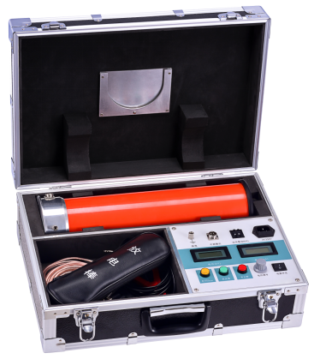
RDZGH-120/X DC High Voltage Generator adopts high frequency power circuit, the latest PWM pulse width modulation technology and voltage current double closed-loop feedback technology, improve the power adjustment rate and load adjustment rate, so that the high voltage stability, low ripple. The high quality and portability of the high quality and portable DC high voltage generator are realized by using imported high power IGBT device and its driving technology. Select of imported high frequency high voltage rectifier diode, so that more compact and portable, improve the efficiency of the whole machine. According to EMI electromagnetic interference and EMC electromagnetic compatibility theory, the use of shielding, isolation and grounding measures to enhance the safety of the whole machine, and can withstand the rated voltage discharge without damage. The instrument protection function is complete, with zero position protection, over current protection, over voltage protection, breakdown protection, protection circuit selection of nanosecond special sensor, the action is fast and reliable, and can effectively protect the body and equipment safety. The digital dial switch is used for the overvoltage setting, and the operation is simple and has higher accuracy. The intelligent high precision 0.75U function button, which is conducive to the test of zinc oxide arrester. This instrument has the advantages of small size, high power, light weight, easy operation, safety and reliability, and high power output quality. It is an ideal testing instrument for detecting the DC electrical insulation strength and leakage current of power devices in the high-voltage testing industry.
- Product features
- Output voltage stability: the use of the latest PWM pulse width modulation technology and voltage current double closed-loop feedback technology, improve the power supply adjustment rate and load adjustment rate, so that the high voltage stability, low ripple. Full range smooth voltage regulator, output voltage high accuracy. The host voltage meter directly displays the voltage value of the load, without additional voltage divider, the wiring operation is simple. Voltage resolution 0.1kV, current resolution 1uA.
- Comprehensive protection: full range of protection function, with zero position protection, over current protection, over voltage protection, breakdown protection, protection circuit use nanosecond special sensors, the action is fast and reliable, and effectively protect the safety of people and equipment.
- 0.75U function: the intelligent high precision 0.75U function button, press this button, voltage current automatically up to the 0.75U state, which is conducive to the oxidation of zinc oxide arrester test.
- Zero boost voltage: the boost potentiometer zero, the use of imported multi - loop potentiometer, the process of stable, high - accuracy.
- Over voltage setting: digital dial switch is used in the setting of over voltage, and the operation is simple, has higher accuracy.
- Integrated design: use of integrated design, the host and the cylinder placed in a box. Select high frequency high voltage rectifier diode, so small volume, improves the efficiency of the whole machine, easy to carry.
- Reliable performance: the key components are high performance imported components, the appearance of the cylinder coated with special insulation materials, electrical performance is good, moisture resistance, no leakage.
- Simple operation: the function of the instrument interface buttons, reasonable layout, clear instructions, easy to learn and use.
Product specifications and technical parameters
Specifications  Parameters | 120/2 | 120/3 | 120/5
Rated voltage (kV) | 120
Rated current (mA) | 2 | 3 | 5
Rated power (W) | 240 | 360 | 600
Weight (kg) | 10
Volume (mm³) | 565*390*190
Height of cylinder (mm) | 535
Output voltage accuracy | ±(1.0%rdg±2dgt)
Output current accuracy | ±(1.0%rdg±2dgt)
Ripple coefficient | ≤0.5%
Work mode | Intermittent use, rated load for 30 minutes
Over load capacity | No-load voltage can exceed the rated voltage of 10% to 10 minutes.  Maximum charge current of 1.25 times the rated current.
Power | AC220V±10% 50HZ
Working environment | Temperature : -10 ~ 40℃
Working environment | Relative humidity: The room temperature is 25 degrees centigrade is not greater than 85% (No condensation)
Working environment | Altitude< 1500 m

