RDYD-5kVA/100kV AC/DC Withstand Voltage Test Device

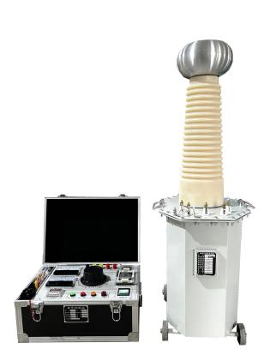
RDYD-5kVA/100kV AC Withstand Voltage Test Device has the characteristics of small size, light weight, compact structure, complete functions, strong universality, and convenient use. It is particularly suitable for conducting insulation strength tests on various high-voltage electrical equipment, electrical components, and insulation materials under power frequency AC high voltage in power systems, industrial and mining enterprises, scientific research departments, etc. It is an essential and important equipment in high-voltage testing.
The operating table (or control console) is the supporting equipment of the high-voltage test transformer. Perform withstand voltage and leakage tests together with the test transformer.
- Performance characteristics
- Oil immersed test transformer has compact structure, stable and durable, and low price.
- Small size, light weight, simple and intuitive wiring, easy to use.
- Good insulation reliability and beautiful appearance.
- Device parameters
Oil Immersed Test Transformer
Capacity（kVA） | 5
Output voltage (kV) | 100 (AC) | 140 (DC)
Output current (mA) | 50 (AC)
Input voltage (V) | 200V
Input current (A) | 25A
Impedance drop | <10%
No-load current | <5%
Manual Control Box
Capacity（kVA） | 5
Input voltage (V) | 220V
Input current (A) | 25A
Output voltage (V) | 0-250
Output current (A) | 20
operating mode | Manual

