RDLC-503XB Three Phases Capacitance & Inductance Tester

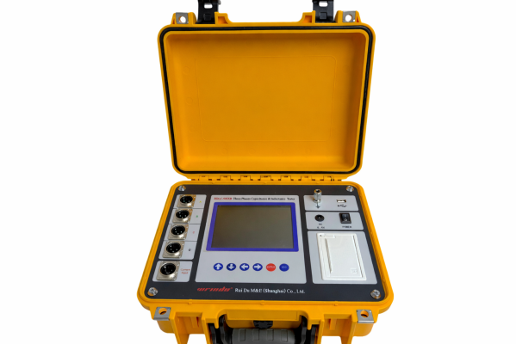
RDLC-503XB Three Phases Capacitance & Inductance Tester is a high-performance, portable specialized compensation capacitor tester designed specifically for detecting compensation capacitors in power systems. It adopts high-precision, large opening clamp current transformers for current measurement, built-in large capacity lithium batteries, and is equipped with an anti-interference power supply output of different frequencies. The testing accuracy is high, the data is stable, and the anti-interference ability is extremely strong, which can be accurately tested in strong magnetic field environments. This instrument can not only measure single-phase capacitors, reactors, and resistors, but also has the function of testing three-phase capacitors. It can measure three-phase capacitor groups with different connection methods with one click and support separate current testing. It can meet the diverse testing needs on site and effectively solve the problems of heavy workload and easy errors in traditional measurement methods, greatly improving work efficiency.
- Product features

- Flexible and convenient power supply: Equipped with a large capacity lithium battery, on-site testing does not require AC power supply, with a battery life of about 8 hours, making it easy and convenient to use.
- Strong anti-interference ability: Using a different frequency power supply for output testing, combined with advanced inverter technology and PID regulation algorithm, it achieves constant current and limited voltage output, soft start and soft stop to reduce sample impact, and output short circuit will not damage the instrument. The testing accuracy is not affected in high-intensity magnetic fields.
- Comprehensive testing functions: Supports single-phase and three-phase capacitance testing, can measure reactors and resistors, and can also perform separate current detection; Single phase measurement can choose automatic testing, and the instrument automatically determines the type of test sample; The three-phase test is aimed at Y-type, Yn type, △ type, and III type connected capacitor banks, and the calculation of phase separation capacitance can be completed with one wiring.
- Intelligent data processing: It can automatically calculate parameters such as capacitance compensation capacity, sample capacitance impedance, inductance, impedance, etc; Current testing can detect the fundamental effective value, total harmonic distortion, signal frequency, and the content of third, fifth, seventh, and ninth harmonics, achieving simple power quality analysis.
- User friendly operation and display: Equipped with a 5.7-inch large LCD screen, menu prompts, and simple operation; The top status bar displays key status information in real-time, the backlight automatically adjusts, and supports remaining battery display and low battery alarm.
- Good portability: small size, light weight, convenient to carry and use on site.
- Product specifications and technical parameters
Item | Description
Capacitance | Range: 0.1 ~ 3500μF; Accuracy: ±(1%rdg+0.005μF); Resolution: 0.001μF
Inductance | Range: 100μH ~ 50H ; Accuracy: ±2%rdg
Resistance | Range: 10mΩ ~ 20kΩ; Accuracy: ±2%rdg
Current | Range: AC 1mA ~ 100A, 30～150Hz; Accuracy: ±1%rdg
Voltage | Range: AC 0 ~ 30V
Display | 5.7-inch LCD screen, 320×240
Data storage | Local storage: 200 groups, supports transferring to USB drive
Power supply | Rechargeable lithium batteries; Charger input 100-240VAC, 50Hz/60Hz.  The charging time is about 4 hours, and the usage time is abou 8 hours.
Operating conditions | Temperature -10 ~ 50℃; Relative humidity ≤90%, no condensation.

