RDKC-201X Transformer On-load Tap-changer Analyzer

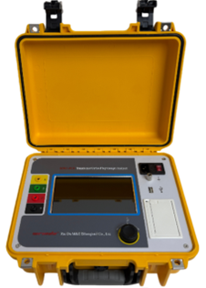
As the only moving component connected to the transformer circuit, the detection of OLTC is increasingly receiving attention. To meet the detection requirements of OLTC, our company has developed the RDKC-201X Transformer On-load Tap-changer Analyzer. This instrument is mainly used to measure key parameters such as the transition waveform, transition time, instantaneous transition resistance, and three-phase synchronicity of OLTC in transformers. The instrument has a high level of intelligence, small size, and light weight, making it an ideal instrument for power supply units and transformer manufacturing industries to ensure safe production and improve product quality.
- Product features

- The tester has a large output current, which can be adapted to test requirements with smaller transition resistance values.
- The tester is equipped with three current output gears, which can meet the testing scenarios of different types of samples.
- The tester is equipped with a complete protection circuit, ensuring strong product reliability.
- The tester is equipped with a 7-inch full touch industrial grade color LCD screen, with a resolution of 1024×600, full view display, and a brightness of up to 400cd/m². It can display clearly outdoors; The touch panel adopts explosion-proof glass, suitable for industrial environments.
- The tester supports both rotating mouse operation and touch operation, and is equipped with a brand new UI display system, providing users with a safe and convenient dual operation guarantee.
- The tester is equipped with a thermal printer to facilitate on-site printing of test data.
- The tester has both local storage and U-disk storage functions, and can be used in conjunction with PC software to make waveform analysis more efficient and convenient.
- Product specifications and technical parameters
Item | Description
Test current output | 1A, 0.5A, 0.3A
Transition resistance | Range: 0.5 ~ 20Ω @1A , 2.0 ~ 40Ω @0.5A , 5.0 ~ 60Ω @0.3A; Accuracy: ±(5%rdg+0.1Ω); Resolution: 0.01Ω
Transition time | Range: 0.1 ~ 300ms; Accuracy: ±1ms; Resolution: 0.1ms
Display | 7-inch full touch industrial grade color LCD screen, resolution 1024×600
Port | USB
Operation method | Rotating mouse/Touch operation
Power supply | AC 220V±10%, 50Hz/60Hz.
Operating conditions | Temperature -10 ~ 50℃; Relative humidity ≤90%, no condensation.

