RDSP-3411 Portable Insulation Oil DGA Tester

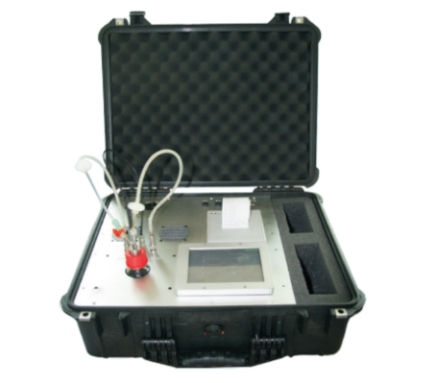
RDSP-3411 Portable Insulation Oil DGA Tester represents a new generation of test equipment for analysis the dissolved gas in oil. RDSP-3411 adopted the advanced infrared photo-acoustic spectroscopy technology and the friendly operation interface. The concentration data of the 7 key fault gases and moisture can be drawn directly within 20 minutes in the field. It really can take place of the Gas Chromatography system in the laboratory because of the accurate, rapid, reliable results. Thus the RDSP-3411 is one of the best tools for evaluating the quality of insulation oil in electrical equipment.
- Product features

- Fast measuring in the field: Within 20 minutes, 7 key fault gases and moisture can be read.
- No consumables: Pure physical photo-acoustic spectroscopy technology, the consumables of calibration gas and carrier gas are needless.
- Moisture in the oil: The concentration of moisture in the oil can be given during the same one test.
- Easy to operate: Touch keyboard operation, simple and easy to operate, no need for training
- Portable and rugged: Weighs <10 kg, in a rugged and convenient carry case.
- Reliable: Engineered design provides inherent reliability and high accuracy.
- DGA diagnosis: International general faults gases diagnosis method, preset the warning limits. Roger’s ratios, Duval's Triangle, IEEE key gases.
- PC communication: External PCs is possible via USB connections, allowing databases to be imported or downloaded.
- Samples: Oil and gas.
- Product specifications and technical parameters
- Detection range and resolution
Gas | Range (ppm) | Resolution
Hydrogen (H₂) | 5.0 ~ 5000.0 | 2ppm NA
Carbon Monoxide (CO) | 1.0 ~ 50,000.0 | 2ppm
Carbon Dioxide (CO₂) | 2.0 ~ 50,000.0 | 0.1ppm
Ethylene (C₂H₄) | 1.0 ~ 50,000.0 | 0.1ppm
Ethane (C₂H₆) | 1.0 ~ 50,000.0 | 0.1ppm
Methane (CH₄) | 1.0 ~ 50,000.0 | 0.1ppm
Acetylene (C₂H₂) | 0.5 ~ 50,000.0 | 0.1ppm
Moisture (H₂O) | ≥5ppm | 2ppm NA
- Accuracy or tolerance: valve <20ppm, ±1ppm; valve ≥ 20ppm, ±10%
- Samples: oil 50ml±2ml, gas 5ml±0.2ml
- PC port: USB
- Printing output: 2 inch mini printer
- Power: AC100~250V, 47~63Hz, 12W
- Host dimension：524mm× 428mm × 206mm

